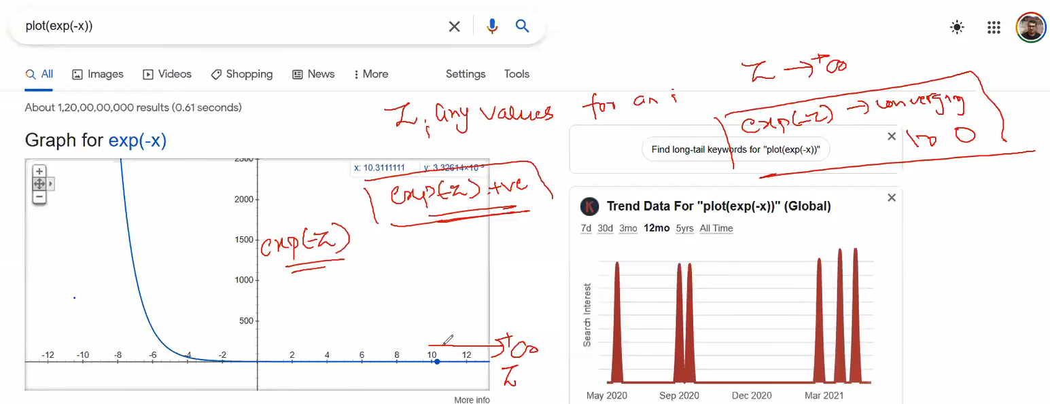

As z tends to be + ve exp(-z) approaches to 0.

We want all the points to be correctly classified, so the cost function>=0

Summarizing

Understanding over-fitting and under-fitting.

Regularization and analysing during over-fitting and under-fitting conditions

Implementation

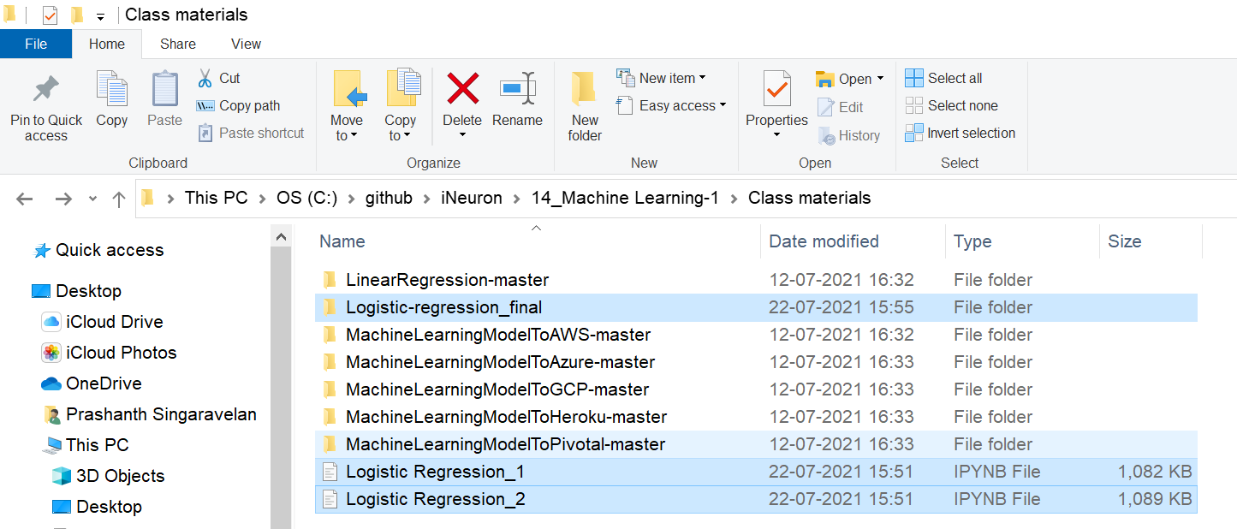

L2 Regularization Will penalize the un-wanted features by making the coefficients 0.

Confusion Matrix

Accuracy and Recall

Precision

True Positive Rate (Sensitivity)

False Positive Rate (1 – Specificity)

Dealing with imbalance data-sets

If we want to reduce FP, go with Precision.  
If we want to reduce FN, go with Recall.

Remember finally you are going to reduce FP and FN.

# **ROC and AUC curves**

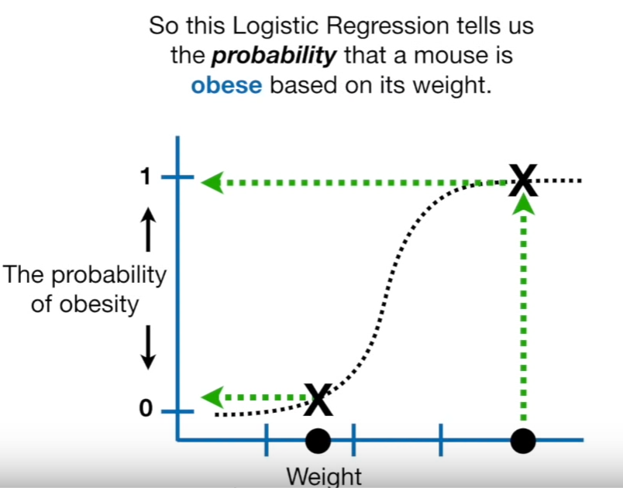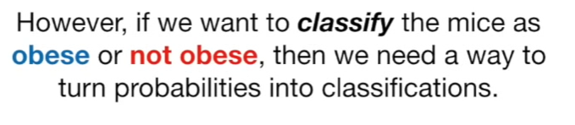  
By setting the threshold=0.5 we classified the sample into obese and not obese.

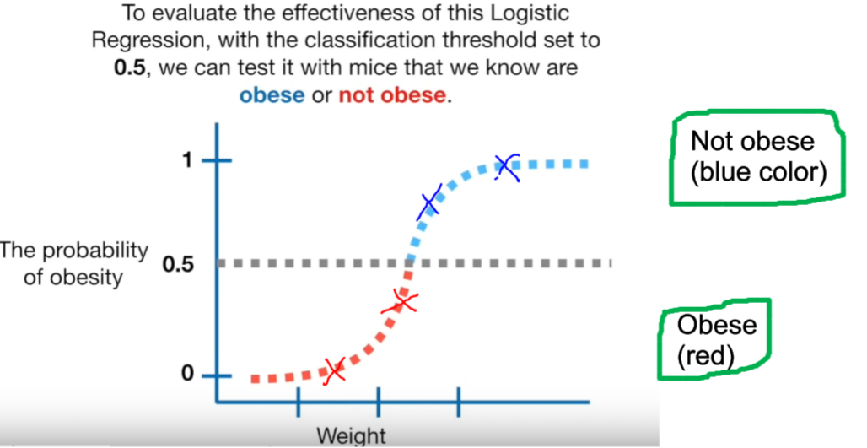

## **Considering the data**

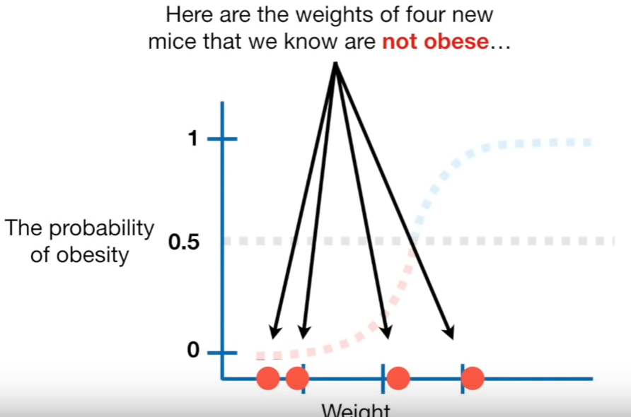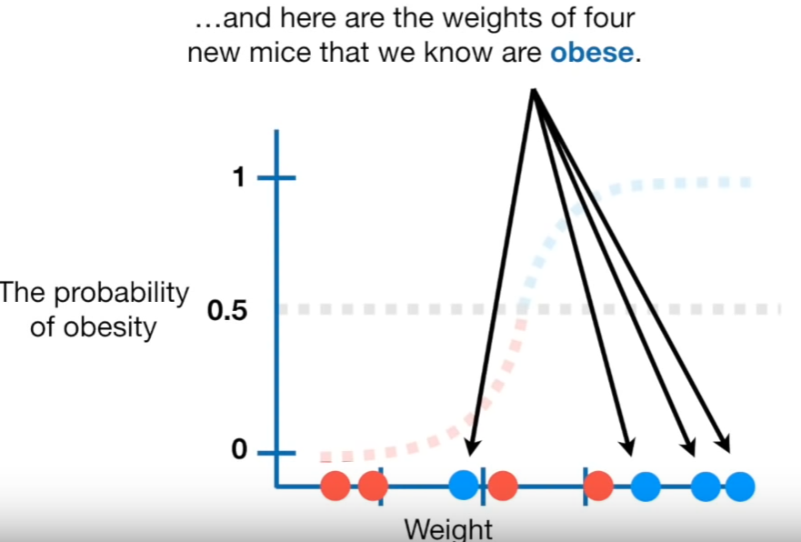

## **Observing via Confusion Matrix**

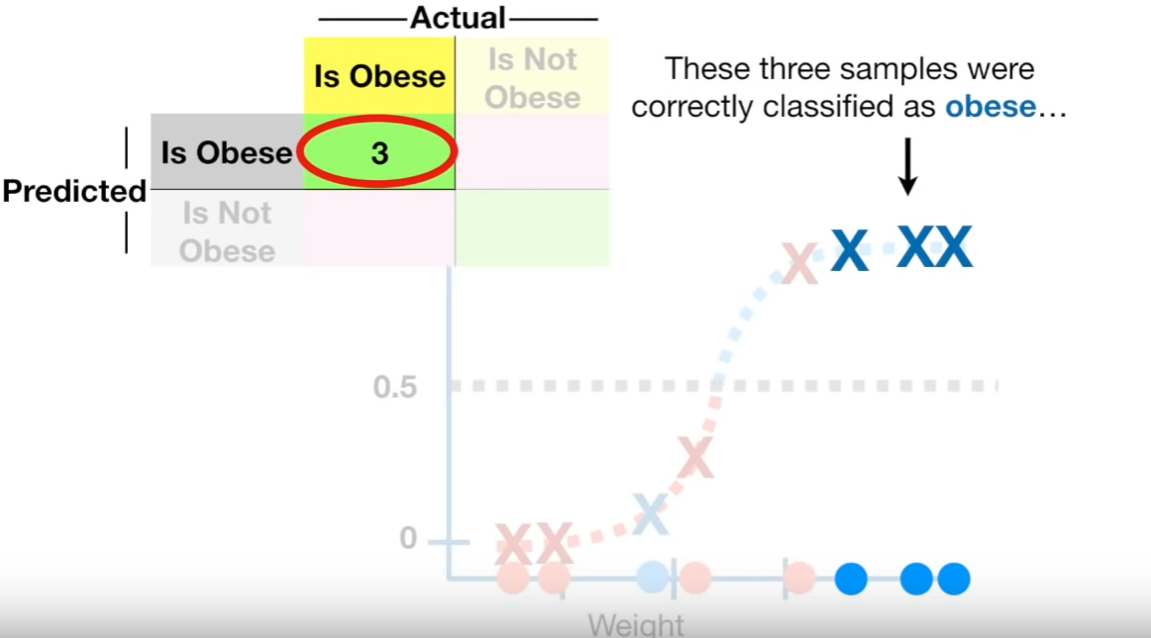  
Correctly classified as obese.

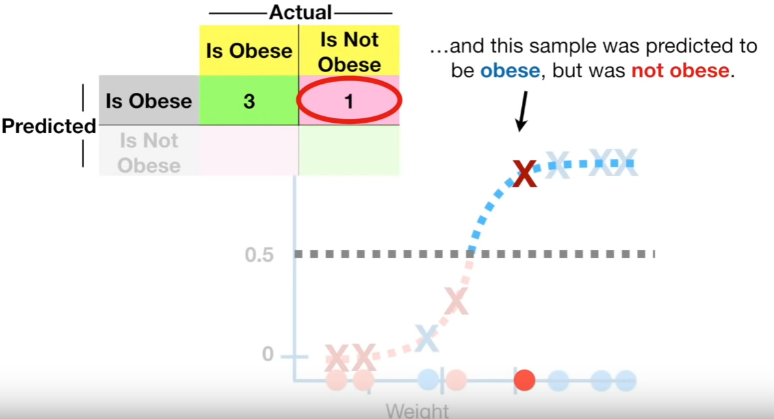  
Predicted 🡪Obese but actual 🡪 Not Obese

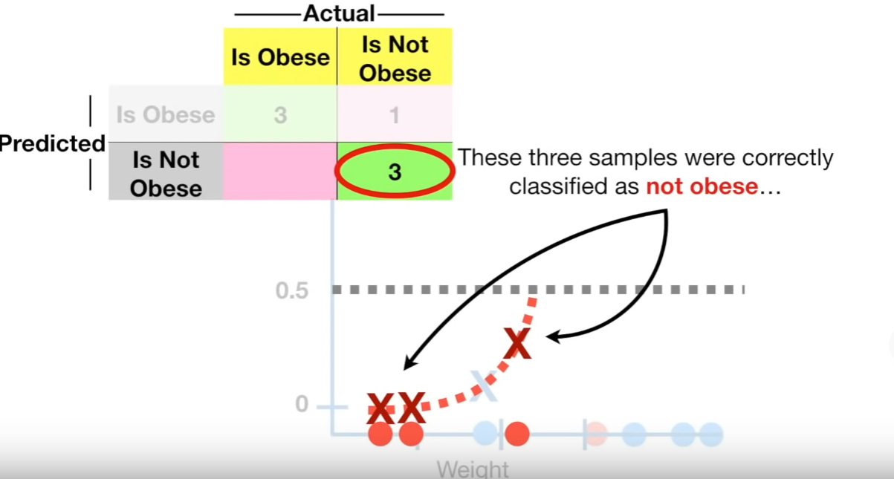  
Correctly classified as Not Obese.

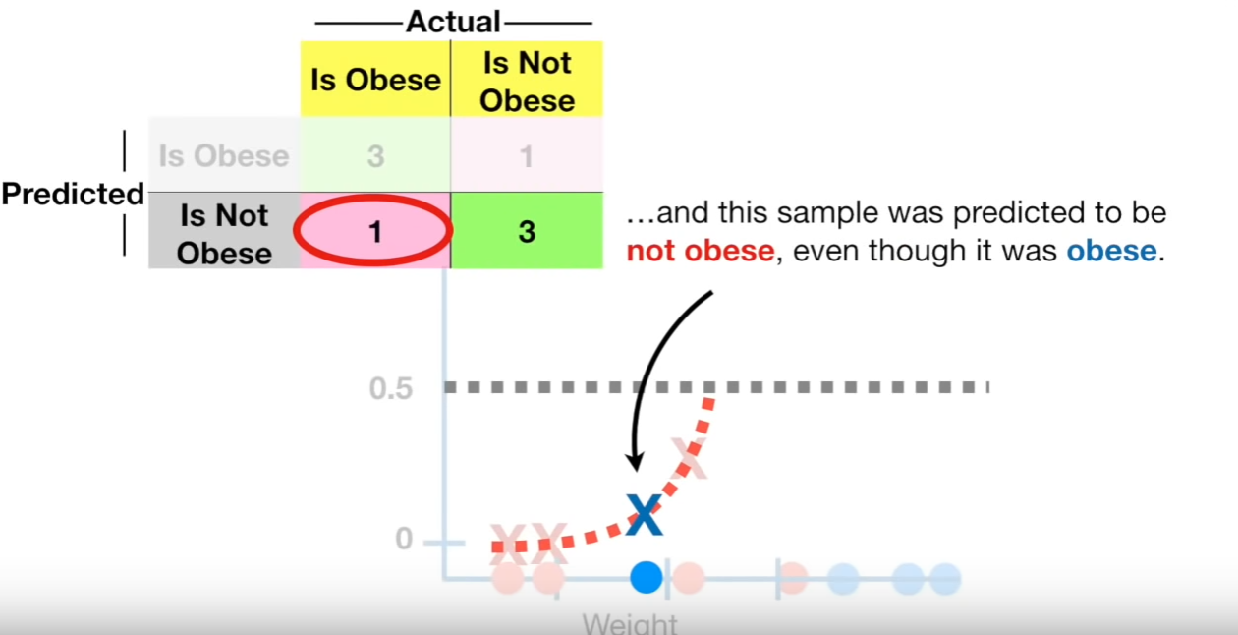  
Predicted 🡪Not obese but actual 🡪 Obese

Then we can calculate Sensitivity and Specifcity.

## **Changing the threshold values**

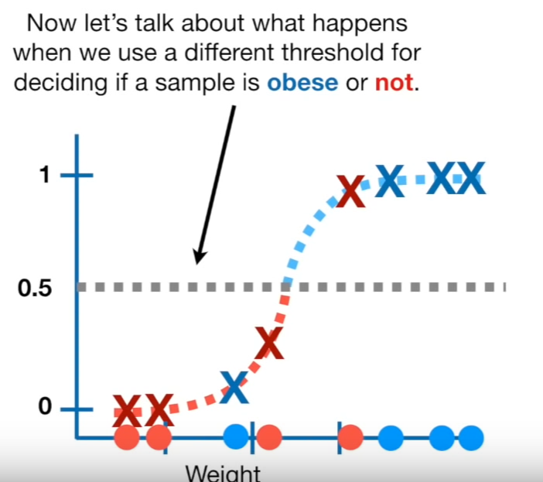

Not lowering and setting the threshold to 0.1  
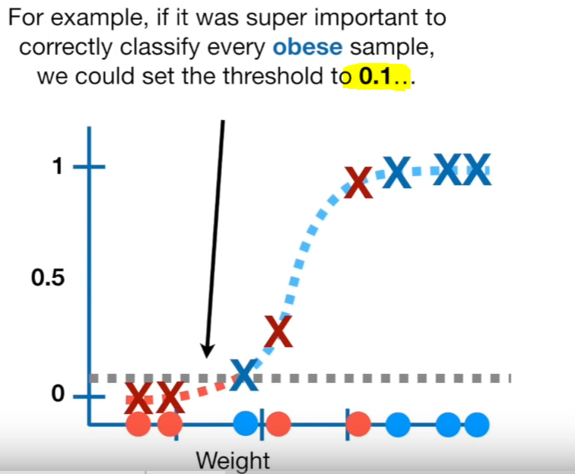  
Now the aim is to correctly classify the obese.

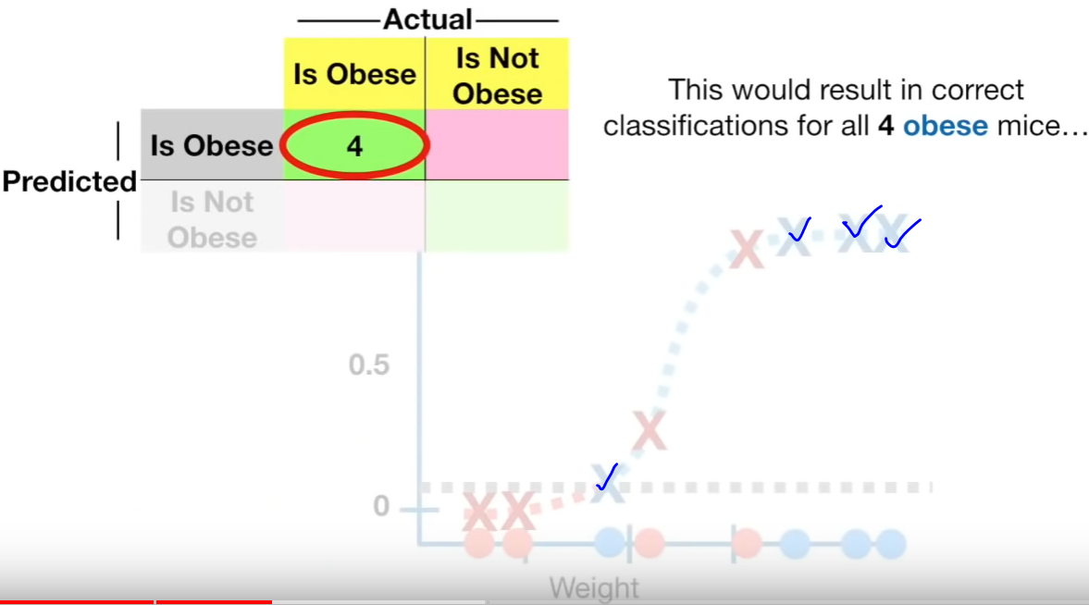

All 4 obese mices are correctly classified.

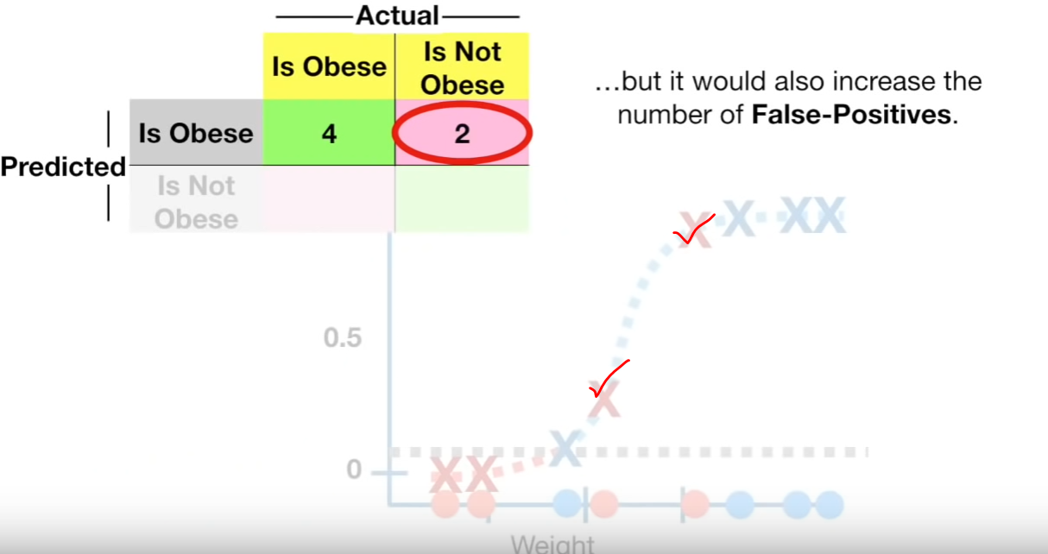

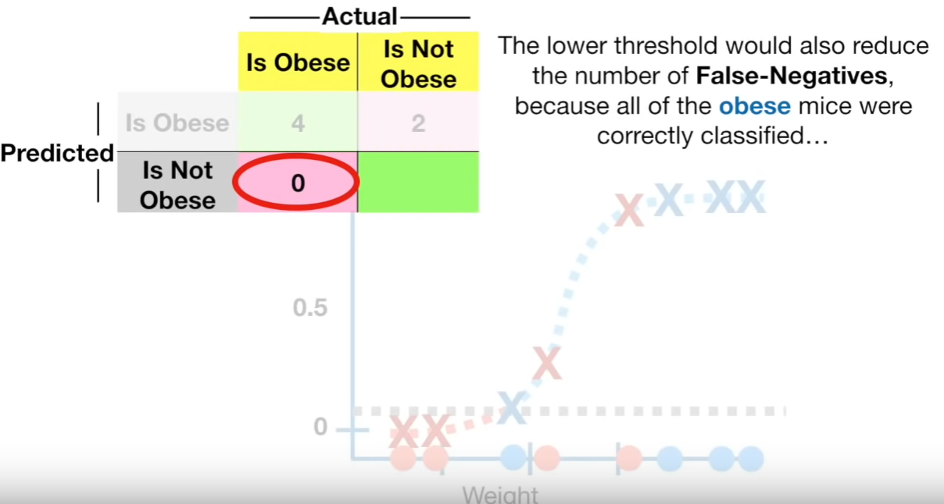

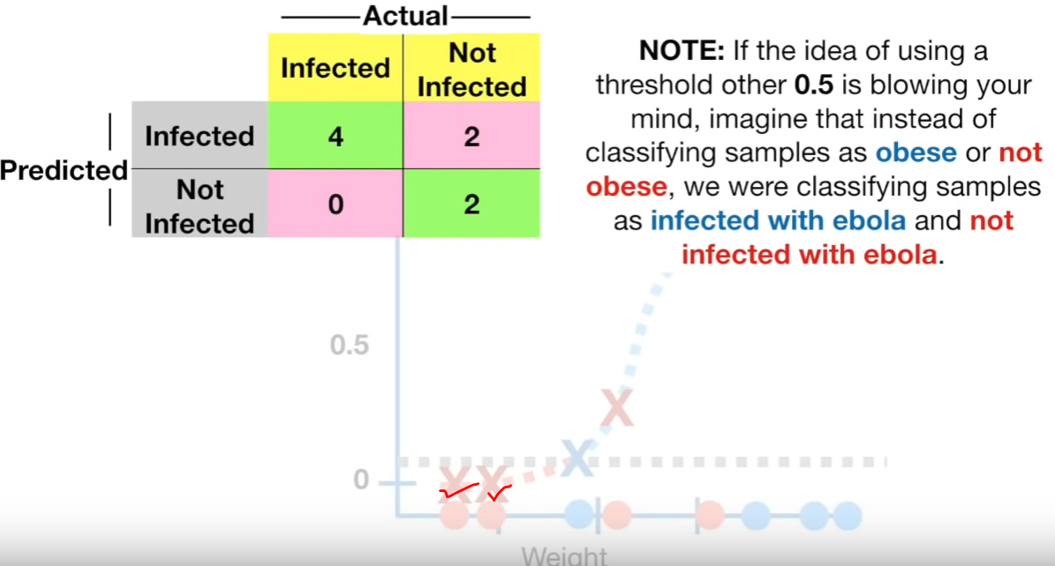

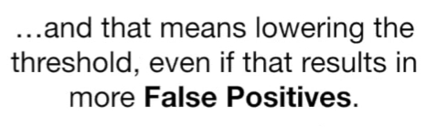  
Lowering the thresholds increases the false positive.

Not increasing and setting the threshold to 0.9.

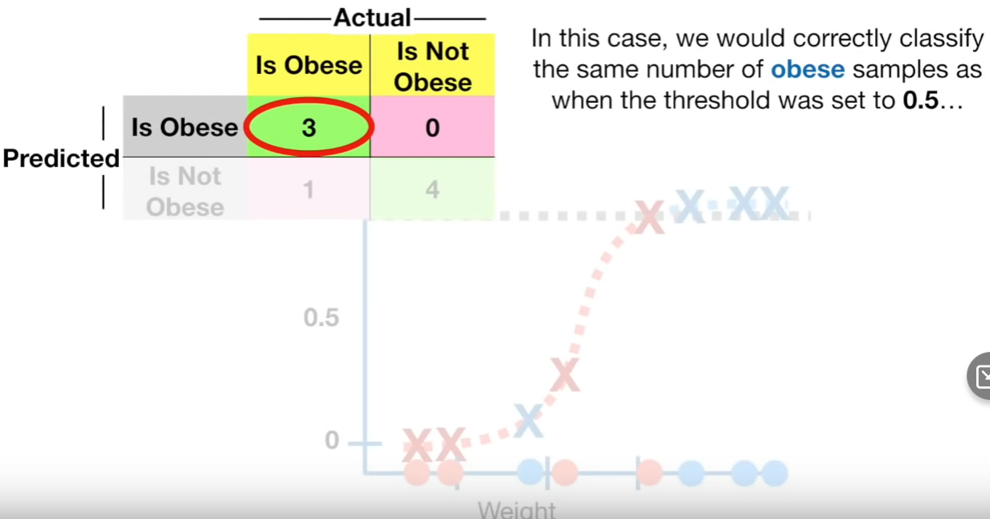

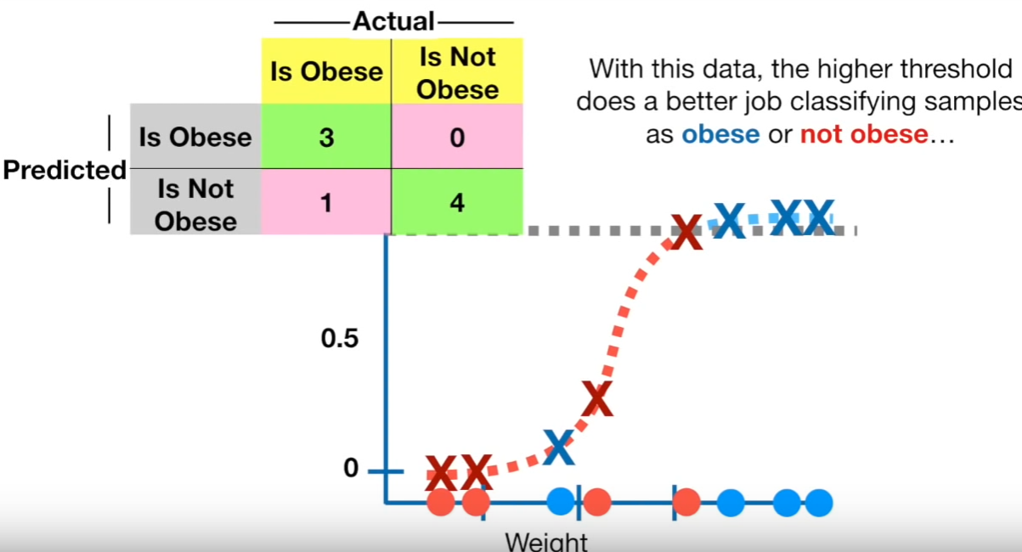

## **How to determine which threshold is best for better classification???** **Y-axis** **X-axis**

References  
<https://www.youtube.com/watch?v=tYZ6cpatw-w>

https://www.youtube.com/watch?v=4jRBRDbJemM